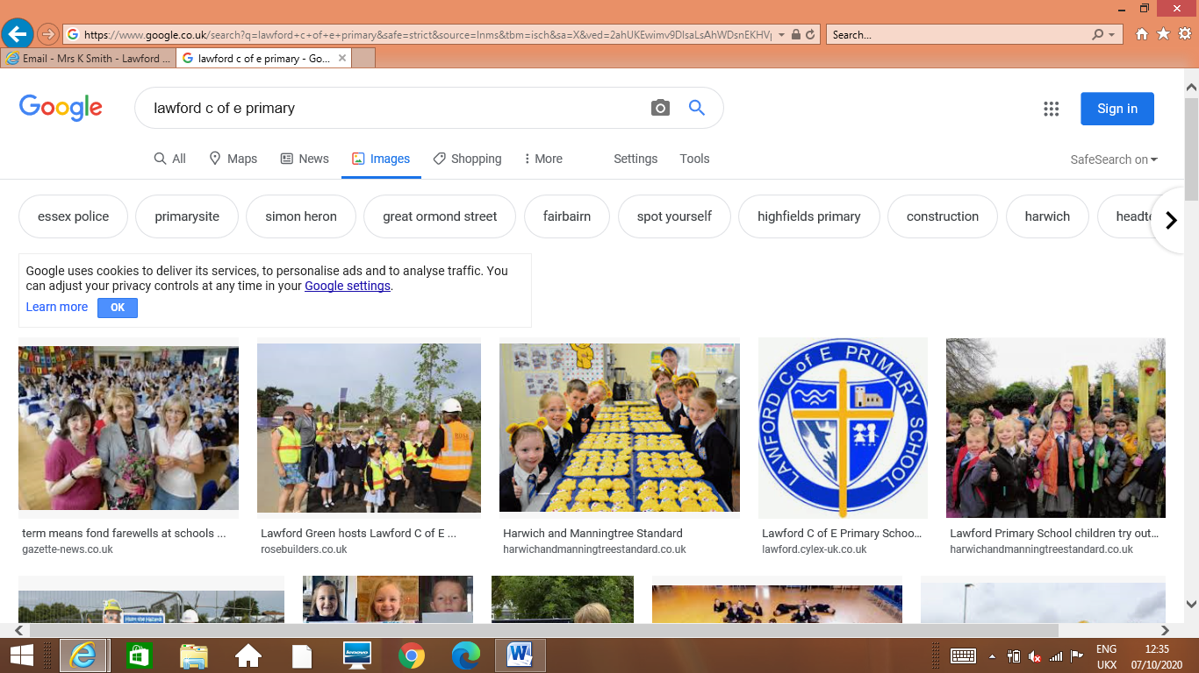

Lawford C of E Primary School

D&T Great expectations 2021-22

*‘High quality learning and caring together in an encouraging Christian environment’*

*A good DT activity should have sufficient breadth and depth to enable pupils to learn practical skills and provide them with the knowledge to make products that move/light up/are structurally sound/are safe and healthy. Pupils need to be able to test, refine and develop products they design and make, to check they work and consider how to improve them if they do not.*

1. Teach a range of skills

Ensure coverage of a range of skills and the progression of skills in the units taught.

1. Follow the D&T process

Teaching should consistently follow the design, make and evaluate 3 step process to ensure children are able to see the process from design to reflection and improvement of the final project.

1. Clear learning objectives and a range of challenge

Learning objectives should be made clear at the start of each lesson, together with a success criteria where relevant. Encourage children to develop practical skills with meaningful context. Children make good progress when the challenge in designing and making becomes increasingly sophisticated, requiring them to think as designers, apply their technological knowledge and understanding of a range of construction techniques.

1. DT health and safety

When planning units of work, ensure that health and safety considerations are made and where appropriate, risk assessments are completed using the agreed format.

1. Assessment

Assessments are to be completed at the end of every term using the ‘*Foundation tracker’.*