 | Autumn 1 | Autumn 2 | Spring 1 | Spring 2 | Summer 1 | Summer 2
EYFS | Digital Skills  (Continuous provision) | Information Technology  What is technology? | Information Technology  Digital Skills | Digital Literacy  (Online safety) | Computer Science  Beebots and Indi Cars | Digital Skills
Cross curricular Tech use | Taking photos, using QR codes – dojo  Imovie – naughty bus | Podcast – eat, sleep, move  CP laptop – busy things | Drawing on J2E – science  Letter formation  White rose- subitising  J2E – bar graph | Greenscreen hungry caterpillar/enormous turnip | Podcast – recount of transport museum  Indie cars – find the tricky words, make a shape | Indie car intervention  Greenscreen – our year in reception  Nearpod phonics
Year 1 | Digital Skills | Computer Science  Algorithms | Digital Literacy  (Online safety) | Information Technology  (Drawing and painting) | Information Technology  (Digital writing) | Digital Skills
Cross curricular Tech use | Nearpod phonics  Signs of the season- photo taking  CP- QR codes  Uploading of J2E | CP- QR codes  CP uploading of J2E  Nearpod phonics | Signs of the season- photo editing  CP- QR codes  Uploading of J2E  1 minute maths- WR Morning trays  Nearpod phonics | 1 minute maths- WR Morning trays  CP QR codes  Uploading on J2E  Queen’s Hat Green screen  Picasso Art | 1 minute maths- WR Morning trays  CP QR codes  Uploading on J2E  Weather forest green screen  Weather forecast podcast  Leaves identification app | 1 minute maths- WR Morning trays  CP QR codes  Uploading on J2E  Weather forest green screen  Nearpod phonics
Year 2 | Information Technology  Digital Skills | Information Technology  Digital Skills | Computer Science  (Scratch) | Digital Literacy  (Online safety) | Computer Science  (LEGO Spike) | Digital skills
Cross curricular Tech use | Greenscreen – Climate Change  Word Wall | Greenscreen – GFoL interviewing characters  Greenscreen – Recording music performance  Map maker to visit key places in GFoL  PolyPad – Shape | Podcast about Similarities and difference of Kenya and UK  Ai and VR in setting descriptions  Internet searches to research  Photo editing – Minibeasts | Fact files on J2E about Nelson Mandela  Greenscreen/iMovie – Riddles | Greenscreen – Poetry (Class Three at Sea) | Podcast – Radio advert for a seaside holiday 100 years ago  Recipes for jam tarts (typed)
Year 3 | Digital Skills | Information Technology | Digital Literacy | Computer Science  (Scratch) | Digital Literacy | Computer Science  (LEGO spike) Happy Traveller
Cross curricular Tech use |  | Green Screen- Literacy - I was born in the Stone Age  Blooket quiz | Microsoft Reading Progress  Introduction to Teams  LBQ - Maths  Blooket / Kahoot Quiz | Green Screen – Newspaper report  Maths on Teams in Notebook  Map maker to visit countries and their capitals  Microsoft Reading Progress | Maths and Literacy on Teams  Green Screen  Microsoft Reading Progress | All core subjects on Teams  Reflect  Green Screen  Microsoft Reading Progress
Year 4 | Digital Skills  Using the laptop  Creating slideshows  Collaborating online on Nearpod / Teams | Digital Literacy  Using software – PowerPoint, Publisher etc.  Online identity, privacy and safety.  Passwords  Online bullying  Photo sharing online | Computer Science  (LEGO Spike) Quirky Creations |  | Information Technology  Using search engines | Computer Science  (Coding games)  Coding – Scratch
Cross curricular Tech use | Teams for all subjects  Publisher for presenting information in RE etc. |  | Use in English to build settings.  Use in science to show concepts e.g. environmental issues, pollination etc. |  | Research in English, History, Art, Geography and Science. | Used to reinforce learning such as animating stories we have covered, or to demonstrate concepts, such as the water cycle.
Year 5 | Computer science  (LEGO spike) Science We cannot see | Digital Literacy | Information Technology | Digital Literacy | Computer Science (coding) | Digital skills
Cross curricular Tech use | Mapmaker – rainforests | Map maker – West Africa | English – creature descriptions
Year 6 | Computer Science  (Coding) | Information technology | Digital literacy  Online safety | Information technology | Information technology – Excel | Computer science  Lego spike & Hour of code Minecraft
Cross curricular Tech use | LBQ  Bare foot computing WW2 coding -  Bletchley Park | LBQ  Sand Box – Air Raid shelters  Green screen – End of unit history report on VE day and humanitarian impact  Desk top publishing task information reports (Canva) | LBQ – sats  WBD – class trailers of favourite books | LBQ – sats  Sand box- create an Antarctic environment  Desk top publishing task (Canva)  Map maker - Use of digital maps – Antartica | LBQ sats  Map maker - Use of digital maps local history project  Excel unit – linked to Flour babies | ½ class Lego spike Science connections

EYFS | Lesson 1 | Lesson 2 | Lesson 3
Autumn 1 | What is technology and where would I find it?  Assessment for learning – Ask the children what is technology?  Introduce pictures of different types of technology using the powerpoint. Encourage conversations, what is it? Where would you find it? What do we use it for?  Watch video - What is Technology? | Basic Technology - Bing video  The children should be able to explain what technology is in their own age appropriate way and give some examples.  Activity – Sorting types of technology into where we might find it  CP – Having a range of tech available (old and new) | How do I use an iPad?  Show the children a school iPad, ask what they notice, and discuss what each button does. Discuss the technology rules; listening carefully, if something comes up which put up your hand and ask an adult.  Hand out the iPads and teach the children how to unlock and lock their iPad.  Explore swiping and discuss the apps. Click on the camera app. Show them how to take a successful picture and view it.  Activity – Take a clear photo of their learning partner and something in the classroom. Practise zooming in and out. Extend- Delete the photo  CP – ipads on offer for children to practise swiping, opening apps and taking photos.  Ipad on stand available to use both hands to access camera | How to scan a QR code  Recap how we use an iPad and take a photo, recap zooming in and out and deleting a photo.  Activity – Teach children how to scan a QR code. Scan the code but do not take a photo.  Teach to scan your j2E QR code and uplod a photo to your journal.  CP – learning station to upload work to j2e. J2E helpsheet for children to follow.
Autumn 2 | Using the interaction whiteboards for Busy Things, Phonics/Maths games and drawing.  Exposure to the iPads during continuous provision to explore prior knowledge.  Apply digital skills during CP.
Spring 1 | How do I stay safe when using the internet?  Recap what the internet is and how we used it when using the iPads.  Children need to know that they can use the Internet to communicate with family and friends.  I can recognise some ways in which the internet can  be used to communicate.  I can give examples of how I (might) use technology  to communicate with people I know.  Discuss how sometimes things come up on our iPad or the internet or we might click on something we shouldn’t. If they ever get a funny feeling in their tummy then they must ask an adult.  We should only use technology with permission from an adult and with them nearby.  Discuss with the children how you can talk to people online, you can talk to people you know but also can talk to people you don’t know. Is that safe?  Talk about how we would talk to our friends online and in person.  Watch the video on CEOP –  https://www.thinkuknow.co.uk/4_7/4-5/badges/watching-videos/ | What is a robot? What is an instruction?  Key word – Algorithm  a process or set of rules to be followed in calculations or other problem-solving operations, especially by a computer  Ask the children what is a robot? How do they work?  Robots LOVE instructions!  Give the class a set of instructions –  Stand up  Sit down  Clap your hands  Stamp your feet  Turn around in a circle  Ask the children what you were giving them? Talk about the word instruction, what does it make people do? Introduce the idea that we can also give computers instructions.  “I am going to be a robot and you are going to give me instructions to move around the room.” Get a child to give you instructions to walk to the toilets. Discuss with the children what we need to give a person to get them in the correct place – clear instructions and use direction words.  Introduce the arrows forward, backwards, left and right.  Directions song - Move Left! Directions Song For Kids - YouTube  CP – Leave direction cards out on the carpet for the children to explore giving instructions to others. | Let’s program the Indi Cars!  Talk about what an algorithm is and how we moved the beebots (skills taught in CP)  Introduce the indi cars and explain how they are a robot and they need instructions to make them move. The indi cars use mats to give instructions. Using the help guide sheet, explain to the children what each mat does. Explore making the indi car move as a class.  Set the children off in groups to explore using the indi cars.  Bring them back together – What do you need to do if your instructions are not successful? Introduce the word DEBUGGING.  Let the children have another go and listen out for children “My instructions did not work so I am debugging”  CP – To use the Indi cars independently
Spring 2 | What is a computer?  Space learning – What was an iPad, what can we use them for?  Let’s learn about how you use another piece of technology.  Share with the children that your computer in the classroom is called a desktop computer and that you also have a laptop. Show theses to the children.  What do you notice is similar and different about a computer and an iPad?  Explain some things we can use a desktop computer for.  Show the children how the mouse and keyboard works.  Activity – Children to use class laptop to access busy things – using the mouse and keyboard to play. | Painting on an ipad  Introduce using j2E Jit to draw a picture. Show how to access it via QR code, use the different tools and save your work.  Activity – to draw a picture on jit.  CP – Continue to set learning stations accessing jit. | How do I use a computer?  Small groups in Computing suite  Skills to practise –  - Turning on the computer  - Holding the mouse (use a sticker on the left button to help clicking skill)  - Logging on (log ins on the wall)  - Double clicking  Log onto the computers and paint. Draw a picture to practise mouse skills.
Summer 1 | How do I use a computer?  Small groups in Computing suite  Skills to practise –  - Turning on the computer  - Holding the mouse (use a sticker on the left button to help clicking skill)  - Logging on (log ins on the wall)  - Double clicking  Another Activity – Children to open word and type their own name  Useful link - Using a computer to write - BBC Bitesize  CP – Use the chrome books in the classroom | How do I program an animation?  Teach children to use animate on jit on j2E. Use the helpsheet to follow instructions to animate their own work.  Activity – children to make their own space animation.  CP- children to practise animate during CP. | How do I use AR?  Introduce AR -Augmented Reality (AR) is a technology that overlays digital information onto the real world, enhancing your perception of reality  Show childrenhow to access sandbox AR app.  Activity – children to make their own AR worlds on sandbox.  Continue to use in CP.
Summer 2 | Digital skills to be covered…  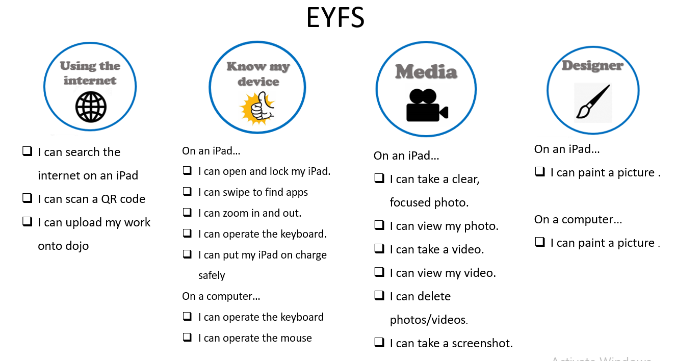

Year 1 | Lesson 1 | Lesson 2 | Lesson 3
Autumn 1  Digital Skills | Please ensure you are recapping EYFS digital skills.  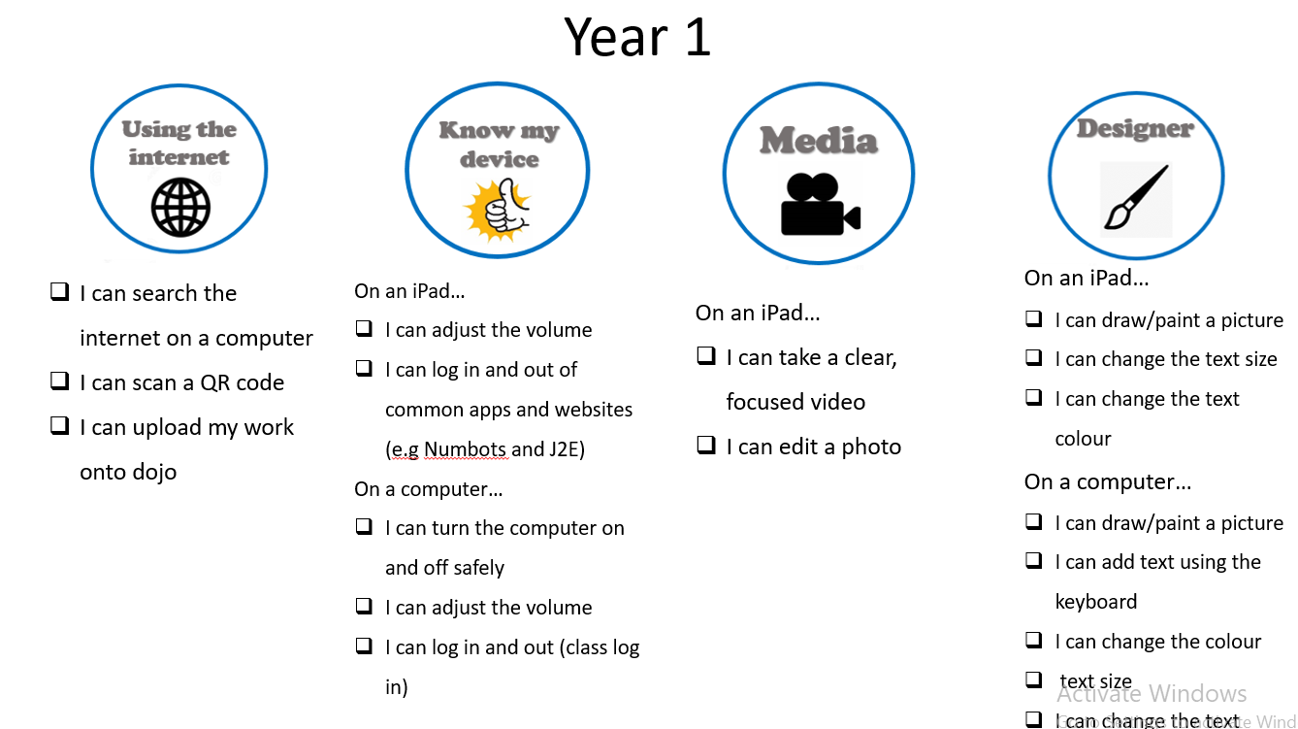
Autumn 2  Computer Science | Can you create an algorithm?  WALT – understand that an algorithm is a sequence of instructions  I can take real-world problems and plan a sequence of steps to solve them.  Spaced learning – Think back to EYFS when you used the beebots and Indi cars, what did these robots need in order to move? Can you remember the word we use to describe the instructions we give pieces of technology?  Tell the children that you are going to make a Jam sandwich but you are going to be a robot and they need to give you instructions to make the sandwich. (Do exactly what they say to show the children how an algorithm needs to be simple, clear instructions)  Useful video - Checking your algorithm | Computer Science – How to Think Like a Computer (youtube.com)  As a class write a sequence of instructions (algorithm) which a robot could follow to make a successful jam sandwich.  Continuous provision – To have the Indi cars and beebots out on offer for the children to develop their computing skills.  Pupils could also create their own mats for the robots.  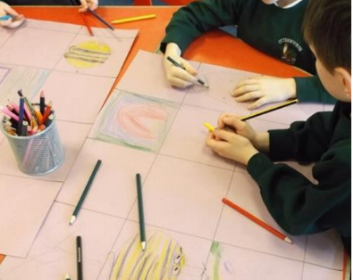  Useful links - What is an algorithm? - BBC Bitesize  How do you program a robot? - BBC Bitesize | Can you follow an algorithm?  - WALT know that algorithms can be implemented on digital devices.  - Recognise examples of algorithms in everyday digital devices.  - Starter - Begin the lesson by engaging the students in a discussion about digital devices they use in their daily lives. Show pictures of different digital devices such as smartphones, laptops, tablets, and game consoles.  - Ask students to name each device and briefly explain what they use them for. Discuss with the students whether they think these devices have instructions or algorithms.  Useful videos to share - What is an algorithm? - BBC Bitesize  Computer Science Basics: Algorithms (youtube.com)  Activity – Using the Indi Cars get the children to follow your preselected challenge cards.  (You can also use beebots and challenge cards)  - Bring the whole class back together and ask each group to share their experience following the algorithm with the device.  - Lead a class discussion by asking questions such as:  - -What did you learn about algorithms from this activity?  - -Can you think of any examples of algorithms in the devices we discussed earlier?  Continuous provision – To have the Indi cars and the challenge cards out on offer for the children to develop their computing skills. | Can you predict the behaviour of a simple program?  WALT predict the behaviour of a simple program.  Starter – Recap what an algorithm is and where they are used. Discuss what we have learnt so far using the indi cars and beebots.  Introduce todays learning -  Model the activity on the carpet.  Using the premade grids and algorithm sheets the children work together to predict the movements. Looking at the algorithm where do they think they will end up? Then prove it by following the algorithm.  Apply activity - Use J2E( JIT5 TURTLE) – write an algorithm on their whiteboard for their partner to predict where the character will end up, their partner can then enter this algorithm to see if they are correct.  (Model this on the carpet with a partner)  Continuous provision – Have a small selection of iPads with J2E log ins so the children can write their own algorithms to follow.
Spring 1  Digital Literacy | What should I post online?  By the end of the lesson, students will be able to:  -Identify personal information that should not be shared online.  - -Understand that information shared online can last for a long time.  - -Know that information which is put online stays for a long time and can be easily copied.  Starter (5 minutes):  Begin by asking the students to share what they know about using the internet, including any experiences they have had. -Discuss with the class some benefits of using the internet and the importance of being safe online.  Input (10 minutes):  1. Introduce the concept of personal information and explain that personal information is information about themselves that they may not want to share with others. Display and explain a list of personal information they should not share online, including:  - Full name  - Address  - Phone number  - School name and class  – Passwords  Activity –Sorting activity - What should I share online? What should I not share online? | How can I be kind online?  By the end of this lesson, students will be able to:  - Recognise that there may be people online who could make someone feel sad, embarrassed or upset.  - Understand why it is important to be kind and respectful online.  - Understand what to do if someone is being bullied online.  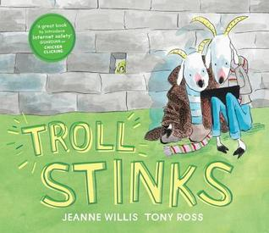  (Lesson slides – Online Kindness)  Troll Stinks - YouTube  Activity – J2E JIT 5  Children to draw a picture and type a sentence on how they can ensure they are kind online.  Useful links - How to be kind online - BBC Bitesize | Why do I need to ask permission when doing something online?  By the end of the lesson, students will be able to:  - -Understand the concept of needing permission to do something online.  - -Identify situations where permission is required.  - -Explain the importance of seeking permission to protect personal and others' information online.  Starter – Discuss the key vocab ‘permission’, what does it mean, what do we have to ask permission to do?  Take a look at the different scenarios using technology, would they need to ask an adult for permission to do this? Why? (Discussion time)  Watch Episode 2 – Sharing pictures  https://www.thinkuknow.co.uk/parents/jessie-and-friends-videos/  Discuss – What mistake did the children make? How did they make the situation better? How can an adult help you if you are in trouble? What must you do before you do something online? What must you do before you share something like a photo?  Activity – Children to record their responses to one of our three key questions and post on their Class Dojo account  -What should I post online?  -How can I be kind online?  - Why do I need permission when doing something online?    Book to share – The Internet is a Puddle
Spring 2  Information Technology | What is technology used for beyond our school?  WALT recognise common uses of information technology beyond school.  Engage the students by displaying pictures of different types of digital devices (e.g., computer, laptop, smartphone, tablet) and asking them to name the devices they see and what they are used for.  Create posters with their ideas for them to refer to later.  - Input – Introduce the concept of information technology by explaining that it refers to the use of computers and other digital devices to process information and communicate.  - Provide examples of common uses of information technology beyond school, such as online shopping, playing games, watching videos, and communicating with friends and family.  - Explain that these activities involve the use of programs and algorithms that enable the devices to perform specific tasks (link to prior learning)  - Activity – Work in small groups to create a collage or poster showing different ways information technology is used beyond school.  - Provide a variety of magazines, newspapers, and printed materials for them to cut out pictures or draw illustrations representing their uses.  They can label each one with some examples of what they are used for.  Continuous provision – Having a range of unused technology available for the children to role play with | Digital painting - Lesson 1  Computing suite - online app Paintz (paintz.app)  WALT -  - I can make marks on a screen and explain which tools I used  - I can draw lines on a screen and explain which tools I used  - I can use the paint tools to draw a picture  Intro - Tell the learners that during this unit they are going to learn how to paint using digital devices. Share the learning objectives with the learners.  Open the painting program and show the learners the different parts of the window:  - The white area is the drawing space  - The buttons at the top/side of the window are called tools, and they all have different jobs  Demonstrate how to draw a picture  Exploration – Children to follow instructions on the board to find the website, give the children time to explore with the drawing tools. Bring them back together and discuss what they noticed, what they found hard.  Discuss what the different tools are used for.  Activity – We are going to try to use the tools we have learnt about to create a picture of ourselves.  - First, show the learners how to clear their image/get a blank page.  - Model the process of drawing a picture of your face, with the learners scaffolding the steps needed to create the picture. “I want to draw a circle for my face. Which tool should I use?/Why? Which colour shall I use? How do I do this?”  - Draw a circle for the face, then colour in the circle using the fill tool.  - Model what happens when you fill a circle that is not fully closed, and show learners how to use the undo button.  - Redraw the circle and ensure that it is continuous and model filling again.  - Tell the learners that you want to add some white for the eyes. Then choose white and keep the paint pot selected. Ask “What happens?/Why?” Remind the learners that they need to go back to using a paintbrush/pencil tool after filling a shape.  - Continue to build up the picture using freehand tools, eg spray can for the hair.  - Remind learners how to get a blank page. Allow learners time to create their own digital paintings.  You should use this time to question learners about the different tools they use.  Children could take a photo of their work and upload it onto class dojo.  Continuous provision – Use the PaintZ app on the chrome books for the children to develop their skills. | Digital painting - Lesson 2  Using shapes and lines  Computing suite - online app Paintz (paintz.app)  WALT -  - I can make marks with the square and line tools  - I can use the shape and line tools effectively  - I can use the shape and line tools to recreate the work of an artist  Intro – Recap their learning from the last session, can they remember what the different tools were for? Discuss how today we will be using shapes and lines to create some digital artwork.  Show the children the artist they are focusing on using the presentation. Model how to use the shapes and lines to create an image and then use the filling tool to add colour.  Activity – Children to create their own interpretation of Piet Mondrain’s artwork.  Galloping gallery to explore each other’s art pieces. Evaluate their artwork and discuss the benefits/negatives to using technology to create artwork.  Continuous provision – Use the PaintZ app on the chrome books for the children to develop their skills.
Summer 1  Information Technology | Digital writing – Lesson 1  Using the keyboard  WALT  - Open a word document  - Recognise keys on a keyboard  - Identify and find keys on a keyboard  Starter – Discuss different ways of writing, what tools can you use? (paper, chalk, whiteboard?)  Show the children a word document and explain that it is very similar to a plain piece of white paper.  Activity – explore the keyboard on a word document setting them the challenge to find particular letters and then write their own name.  Continuous provision – Use the word document on the chrome books for the children to practise their skills | Digital writing – Lesson 2  Adding and removing text  WALT  - I can enter text into a computer  - I can use letter, number, and space keys  - I can use backspace to remove text  Starter – Explore the finger space bar and backspace bar and explain to the children what they are for.  Activity - Children to open up a word document ready for their challenge to create a poster for a lost teddy bear. (powerpoint clearly explains the process to the children)  Children to write a sentence about the teddy and then type a phone number.  Challenge – What changes would you make to the poster (on presentation)  Continuous provision – Use the word document on the chrome books for the children to practise their skills | Digital writing – Lesson 3  Making changes to the text  WALT  - I can select a word by double-clicking  - I can select all of the text by clicking and dragging  - I can change the font  Starter – Children to open up a word document and write their name independently.  Input – Show the children the different ways of changing their text, size, font, italics, bold, underlined.  Teach then to DOUBLE CLICK on a word to highlight it.  Activity – Let the children explore changing their name in different ways.  Quiz – How have I changed the word Ted?  Continuous provision – Use the word document on the chrome books for the children to practise their skills
Summer 2
Digital Skills

Year 2 | Lesson 1 | Lesson 2 | Lesson 3
Autumn 1 | Types of information technology  WALT: recognise the uses and features of information technology.  What computers they have used or seen in school? (tablets, laptops, and desktop computers)  Slide 4 – What ways are the devices similar? (They all have a screen, they have buttons etc.)What are different about them?  Look at the chrome books – What parts can you see? What do these parts do?    PADLET -  What is information technology? Information technology is anything that is a computer or works with a computer.  Look at the ‘Odd one out’.  Activity – Computing room  Download IT or not IT document  Complete the stem sentence to describe what IT is. Refer back to the learning objective. | IT in School  WALT: identify the uses of information technology in the school.  Recap last session – What was IT? Quick recall of what is IT using pictures.  Discuss what IT we have in school and what we use them for. Then introduce Activity 2.  What would life be like without IT?  What examples of IT can you give that are used for the following things:  - Communicating with other people  - Playing on or watching things  - Helping you do a job  Activity 1 - Post it notes on the board – What IT do we have in school?  (Gather thoughts which way was better to gather ideas? PADLET or post it notes?)  Activity 2 – To help you do a job OR to talk to people.  Resizing images and putting them into the correct boxes (needs to be on all children’s devices)  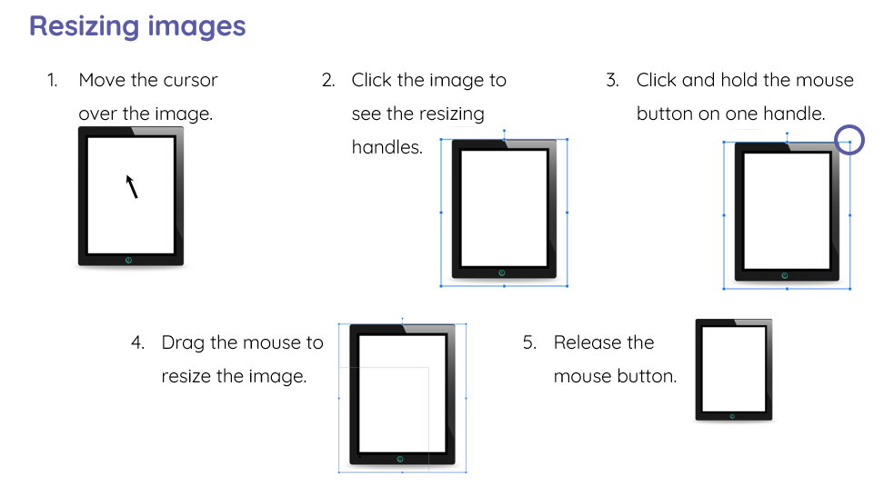 | IT in the wider world  WALT: identify information technology beyond school.  Learning conversation - What type of IT do your family use for work? What is it used for?  Thumbs up, down – Would you find IT here?  (This session is heavily discussion based, ideas could be recorded on sticky notes)  Activity – IT in public places  What would you find here?  Drag the IT to whether you would find it inside or outside.  Challenge – Can you think of any job which do not use any form of IT?
Autumn 2  RADIO STATION FINAL PIECE | Benefits of using IT  WALT: recognise the benefits of information technology.  Discuss how technology has changed briefly -  How computers have changed - BBC Bitesize  Identify what about IT benefits our lives, think about a shop, what IT is beneficial to us?  Does tech make our lives easier? Consider any negatives about tech.  Activity – Children to record each other sharing their ideas about the benefits of IT in the world. | Using IT safely  WALT: know how to use information technology in different ways and how to keep safe  Starter – Creating spider diagrams of different devices and their uses. Children to think of the potential dangers of these uses and how they could keep themselves safe.  Go through the scenarios, children to discuss what mistakes are being made.  Activity – Come up with a list of IT rules. Children to write them up on a word document and change the font/size. | Radio Show  (final collaborative piece)  Planning out an interview of all that has been learnt.  Small talk - Small Talk | Technology | CBC Kids - YouTube  One person being the interviewer, one person answering the questions.  What is information technology?  What types of IT do you have at your school?  What types of IT do we have in our world?  What are the benefits of IT?  Are there any negatives about IT?  How can you ensure you stay say whilst using IT?  Is there anything else you’d like to tell me about IT?
Spring 1 | How can I debug an algorithm?  Discussion about ‘What is computer science/coding?’  Put the words ‘algorithm’ up on the board, what does this mean?  What is an algorithm? - BBC Bitesize – Take a look at these videos. Discuss with the children that they need to be ‘clear’ instructions.  Activity - Look at the beebots, recap what they do, how we move them. Show the children the Indi cars. Give the children time to explore the cars.  How did you fix a problem with the Indi cars? (introduce the word debugging)  What did ‘Debugging’ mean?  What is a bug? - What are computer bugs? - BBC Bitesize | Knock, Knock Joke Session 1  Scratch Jr  See Barefoot planning for this session | Knock, Knock Joke Session 2  Scratch Jr  See Barefoot planning for this session  Homework – Children to be set a ScratchJr linked activity to continue their new skills.

Spring 2 | Keeping Personal Information Private  Lesson objectives -  - Understand that information shared online can be seen by others.  - Identify who they should ask before sharing personal information online.  - Discuss ways to use technology safely and keep personal information private.  Starter – Explain to the children that we are going to set up an online profile, what can we put on there? What information should we not share online? (spaced learning from Y1)  Book link about keeping passwords safe (new learning)  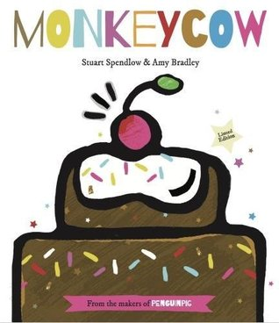  Activity – Children to find images online of things which they could share about themselves online.  Skill – Copying and pasting | Making friends online  Lesson objectives -  -I can explain how other people make look and act differently online to offline  -I can give examples of issues online that might make someone feel sad, worried, uncomfortable or frightened.  -I know how someone might use technology to communicate with others they do not know and know the risks.  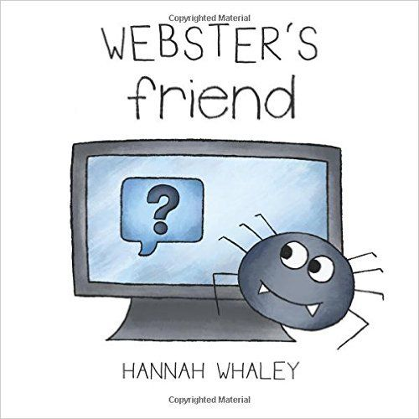  Read Websters friend  Discuss what Webster did which was wrong and how his lies made him seem like a different person.  Watch - ‘Playing Games’ on Thinkuknow  (This lesson links with PSHE unit lesson)  Explore the idea that people can act differently online and how you shouldn’t speak to strangers. (record verbal responses into PSHE floorbook)  Activity – Kahoot quiz | What is Cyber Bullying?  Lesson objectives -  -I can explain what Cyber Bullying is and how I can react to it if I experience or see it  -I know who I can ask for help if I make a mistake online.  Clarify the difference between bullying and cyber bullying - What's Cyberbullying? (youtube.com)  Emphasis that difference between bullying and being unkind. (discuss how making a mistake online requires an adult to help you)  How do I need to react to Cyber Bullying?  Is it Cyberbullying? (youtube.com)  Activity – Explore the different scenarios, children to act them out and record them on iMovie. Record a second video of how you can react to try and stop the Cyber Bullying.  (skill – edit an iMovie)
Summer 1 | https://education.lego.com/en-gb/lessons/spikeessential-great-adventures  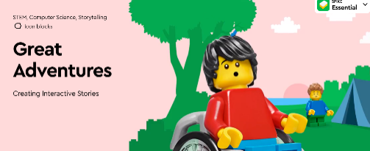  This unit introduces pupils to computational thinking. They'll begin to understand what a sequence is, be able to follow instructions to create a sequence and describe the sequence to their peers. They'll learn how to break problems down into smaller parts (decomposition), identify cause and effect, and understand simple loops. Finally, they'll explore the process of testing and debugging programs to ensure that their programs work as they’ve intended.  7 x lessons 30-45 mins
Summer 2 | Digital Skills  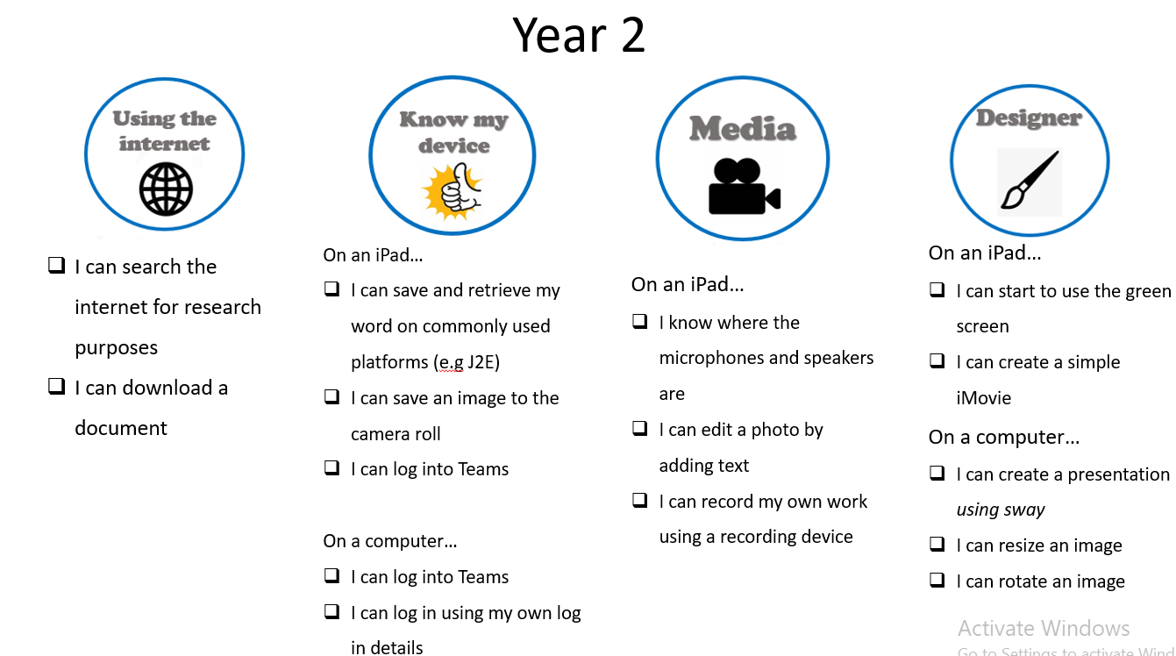

Year 3 | Lesson 1 | Lesson 2 | Lesson 3
Autumn 1 | Digital Skills  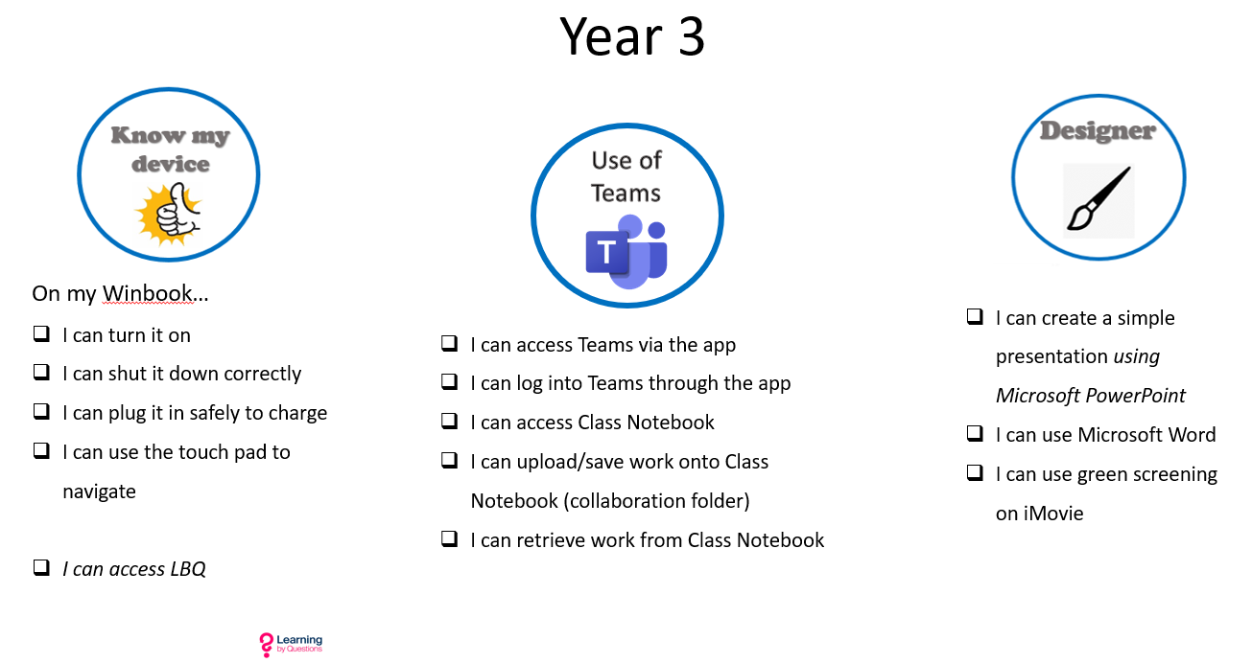
Autumn 2  Information Technology | What are input and output devices?  - Starter:  - Display images of various input and output devices on the board.  - Ask students to discuss in pairs what they think each device does.  - Input:  - Introduce the terms 'input' and 'output' devices.  - Define input devices as tools that send information to a computer, and output devices as tools that display or produce output from a computer.  - Discuss common examples of input devices, such as keyboards, mice, and microphones, and output devices, such as monitors, printers, and speakers.  - Activity:  - Access the PowerPoint on Teams in pairs to then categorise the devices into input and output categories and explain their choices.  - Plenary:  - Ask each group to present their categorisation to the class.  - Encourage discussion and justification of their choices.  Useful Video - CS Basics: Input Process Output (youtube.com)  Useful website - What are input and output devices? - BBC Bitesize | ​What parts make up a digital device?  Starter:  Recap input and output devices as a class (on the PowerPoint)  Match input, device, and output (independent task to be placed into their Teams account to access in pairs)  Explain to learners that in this activity, they will match up inputs, digital devices, and outputs. Explain that the items named on the slide have been sorted as they were in the Venn diagram, but this time, they have been arranged into columns, and learners will draw connecting arrows between items in the different columns that match up.  Using the animation on slide 7, give examples of where there is a connection between one input, one digital device, and one or many outputs, each time articulating the whole sentence, eg:  - “Pressing the keys on the keyboard (input) of a laptop (device) can change what you can see on the screen (output).”  - “Pressing the keys on the keyboard (input) of a laptop (device) can also make a speaker (output) play sounds, or it can make a printer (output) print something.”  Give an example of where there is a connection between one input, one or many digital devices, and one or many outputs, articulating the whole sentence, eg:  - “Tapping on a touchscreen (input) of a smartphone or tablet (devices) can make its screen (output) display something and make its speaker (output) play sounds.”  Invent your own digital device  Explain to learners that they are now going to use their understanding of inputs and outputs to invent their own digital device. Some ideas are provided on slide 8, but learners can also think up a completely different invention. Tell learners that they must consider how their invention will work, including what inputs it will need (for example, it could have a button or a screen), and what its processes will be.  Once learners have completed their designs, invite them to share them with other learners, explaining how their devices would work. | Hardware vs Software  Starter –  Recap game on winbooks - Input, Output and Storage devices - Group sort (wordwall.net)  Main input – Introduce the vocabulary hardware and software, show the children the posters. Discuss the differences. Computer Science Basics: Hardware and Software (youtube.com)  - Activity – Sort the hardware and software pictures, this could be done on paper or digitally (digitally children could find the pictures via the internet and sort on a word document)  - Applying learnt knowledge -  - Look at the following tasks, what would be the most suitable software?  - -Create a colourful poster  - -Write a short story  - -Solve a jigsaw puzzle  Pick one and show me how!
Spring 1  Digital Literacy | Online identity – How can I be me online?  Follow the plan here - Ages 7-11 - Lesson plan.pdf  This is a great website about Online identity - Online Identity | Childnet | What does it mean to ‘know’ someone online?  Begin with a question: "How many of you have friends you’ve never met in person?"  Have students share examples of online friendships or connections.  Read Digi Duck’s Famous Friend  Digiduck’s Famous Friend by Childnet1995 - Issuu  Discuss the story and how you don’t always know who you are talking to because sadly people do lie online.  Go through the Trust it Tips (Powerpoint) and answer the questions on the quiz.  Use Chatterpix app (on all ipads) for the children to take a picture of a character they have drawn and record detailed Top tips for being safe when talking to people online! It may be useful to write a class list before doing this.  How to use chatterpix (this is off a pop up gremlin however you can see how to use it) - https://www.youtube.com/watch?v=fYyDAH_kBL4&feature=youtu.be  Pupils upload their videos onto their Dojo account | How can we be respectful and responsible online?  How do you show respect in a face to face situation?  Go through the BBC bitesize page, some great bits on there!  How can we be respectful and responsible online? - BBC Bitesize  Watch the R is for Respect video...  R for Respect Film | Childnet  Activity – Conflict cards  Children to work in pairs with the conflict cards and decide what they need to do in each scenario, use the first page as a reminder of the things you can do in order to be respectful and responsible when online.  Share their ideas with the class.
Spring 2 – Lego Spike | LEGO Spike  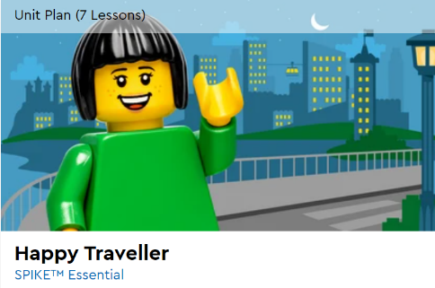https://education.lego.com/en-gb/lessons/spikeessential-happy-traveler/  This unit will develop your pupils' understanding of computer science as they create sequences and loops, decompose problems, and improve programs in order to meet specific needs. They'll investigate ways of accurately describing the decisions they've made when creating a program, carry out fair tests and develop their ability to generate and debug multiple solutions.
Summer Digital Literacy | Sharing online  Starter – How do we use digital technology?  How do we use digital technology? - BBC Bitesize  Pupils to share their ideas of how we use digital technology on a Nearpod collaboration board (Teacher needs to set up)  Input – Spaced Learning – What can we share online about ourselves? What can we not share about ourselves?  Online identity - Self image and identity – an introduction and overview for KS2 (7-11) - BBC Bitesize  Watch the video - T for Trust Film | Childnet  Discuss what information was shared which she shouldn’t of?  Activity – Role play chatting online, one scenario where a person shares personal info and another where the person say no and reports this to an adult. Record this using imovie as a tool to teach others. | The importance of permission  Starter – Do I need permission? discussion points based on access to technology (powerpoint)  When online we also must ask permission of others if we are sharing something about them. We as a school ask your parents' permission to share photos or videos of you on class dojo or social media.  Video - S for Safe Film | Childnet  Video - Discuss how it made her feel when they didn’t ask her permission to share the video, how would you feel?  Activity - In groups discuss the different gaming scenarios and come up with responses – record their responses on a Nearpod collab board | Cyber Bullying  What is online bullying? - Online bullying – an introduction and overview for KS2 (7-11) - BBC Bitesize  Story - Technology Tail Read Aloud  Discuss how the technology tail is the same as the digital footprint.  Talk about ‘keyboard courage’, what does that mean?  Activity – Create a sway covering these headings...  What is cyberbullying?  Cyberbullying makes people feel...  One way to stop cyberbullying is...  Sway to be added to their dojo portfolio  Video for adults on how to use sway - https://youtu.be/x0Unqc5NWK0?feature=shared
Summer 2 Scratch – Loops | Repetition Loops and forever loops  (2 seperate lessons)  How to use forever and repeat mode on Scratch - Scratch Coding - How to use Repeat and Forever loops in Scratch  Recap (this may need to be its own lesson) – Recap what they learnt in ScratchJr in Year 2, allow them to explore on Scratch and see what they can remember.  Scratch - Imagine, Program, Share  See presentation | Repeat until loops  How to use repeat until - Scratch Block Basic - repeat until block  See presentation | Loops in Games  See presentation

Year 4 | Lesson 1 | Lesson 2 | Lesson 3
Autumn 1  Digital Skills | 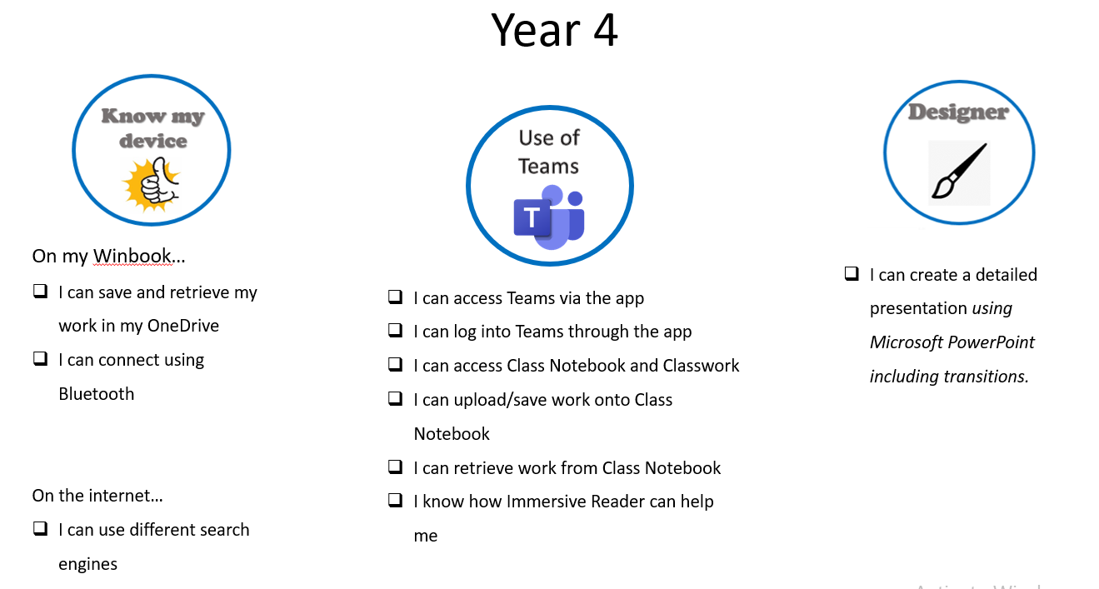
Autumn 2  E-safety | WALT explain the importance of privacy and how it is needed to keep both ourselves and others safe.  Children learn about strong passwords, personal information, and how data can be copied or shared without permission. | WALT explain how our online identity can be different to our offline identity.  Children explore the concept of identity and how people present themselves online, including discussion of avatars, usernames, and digital footprints. | WALT describe ways people can be bullied through a range of media (e.g. image, video, text, chat).  Children learn to recognise and respond to different forms of online bullying and discuss appropriate ways to seek help.
Spring | LEGO Spike  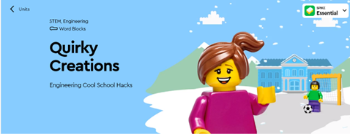  https://education.lego.com/en-gb/lessons/spikeessential-quirky-creations  This unit will develop pupils' engineering design skills as they investigate ways of defining problems, brainstorming solutions and testing and refining prototypes. They'll refine their problem-solving skills as they create a solution to a problem that has constraints and improve upon others’ ideas. They will practice their ability to identify failure points and success criteria when comparing, modifying and evaluating a solution.  The pupils will improve their communication skills as they engage in a range of collaborative discussions about their solutions.  7 x lessons 30 -45 mins
Summer 1  Information Technology | WALT understand how results are selected and ranked by search engines.  Children investigate how search engines work, experiment with key terms, and begin to question the reliability and ranking of online sources. | WALT use technology responsibly and understand that communication online may be seen by others.  Children reflect on the permanence of online communication and practise respectful digital behaviour (e.g., in collaborative documents). | WALT use a variety of software on a range of digital devices with support.  Children work on creating digital documents, presentations, and media projects using common tools like PowerPoint, Word, and online drawing apps.
Summer 2  Coding – producing games | WALT use logical reasoning to detect and correct errors in algorithms and programs.  Children write code in Scratch, identify bugs, and discuss how to debug through logical thinking and testing. | WALT select, use and combine a variety of software, systems, and content to accomplish given goals.  Children create multi-step projects using Scratch or other visual programming tools, combining sound, movement, and control to meet a set challenge. | WALT create and adapt simple programs that include sequences, loops and conditions.  Children apply their coding knowledge to build simple games or animations, including character movement, scoring, and user interaction.

Year 5 | Lesson 1 | Lesson 2 | Lesson 3
Autumn 1  LEGO Spike  Computer science | 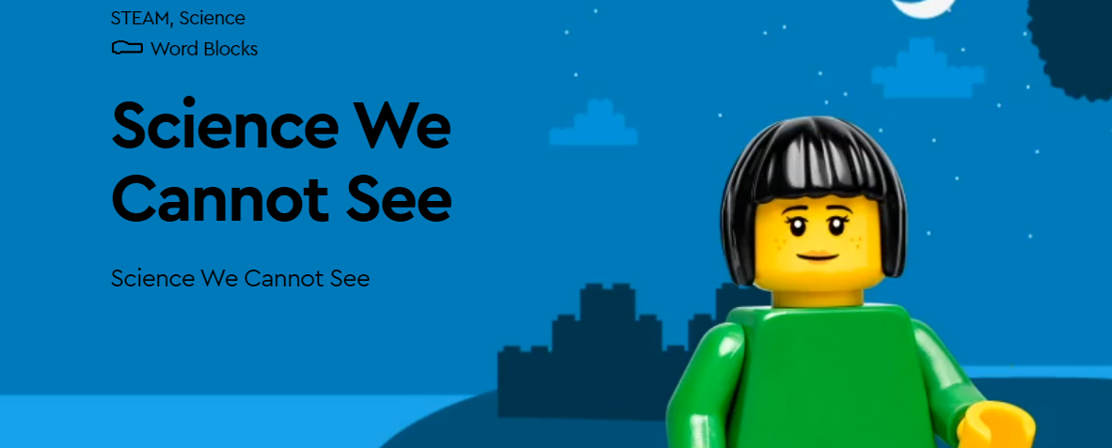  This unit introduces your pupils to ideas about matter, forces, Earth and space, habitats and animals. They'll explore evidence that matter is made of particles too small to see. They'll learn about gravitational forces on Earth, investigate how the number of daylight hours varies during the year, and research ways to use science ideas to protect Earth’s environment. Finally, they'll create a model to show that energy in animals’ food was once energy from the sun.  Your pupils will also practise their social and emotional learning, such as self-regulation, persistence, empathy, self-awareness and mindfulness with the main characters in the lesson stories.
Autumn 2  Digital Literacy | WALT: Understand the need to select age-appropriate content online.  Interland?? | WALT describe how shared items online can lead to unintended consequences and identify ways the internet can push certain agendas. | WALT understand operational security measures like actions following lost/stolen passwords SOFTWARE –  Publisher
Spring 1  Information Technology | WALT independently select and use appropriate software for a task. (VECTOR Pictures  More than 3 lessons | SOFTWARE –  Canva | WALT independently select, use and combine a variety of software to design and create content for a given audience.
Spring 2  Digitial Literacy  AI???? | WALT demonstrates responsible choices about my online identity, depending on context. | WALT explain strategies to protect 'digital personality' and online reputation.  WALT identify a range of ways to report concerns about content and contact in and out of school. | WALT give examples of technology specific forms of communication and explain potential risks of communication online.
Summer 1  Computer Science | WALT solve problems by decomposing them into smaller parts. | WALT create programs that use variables, sequences, selections, and repetitions. | WALT use logical reasoning to detect and correct errors in algorithms.
Summer 2  Digital Skills | Begin to use Touch Typing  Possible resources for independent learning - Learn Touch Typing Free - TypingClub  Dance Mat Typing for 7 - 11 year olds - BBC Bitesize  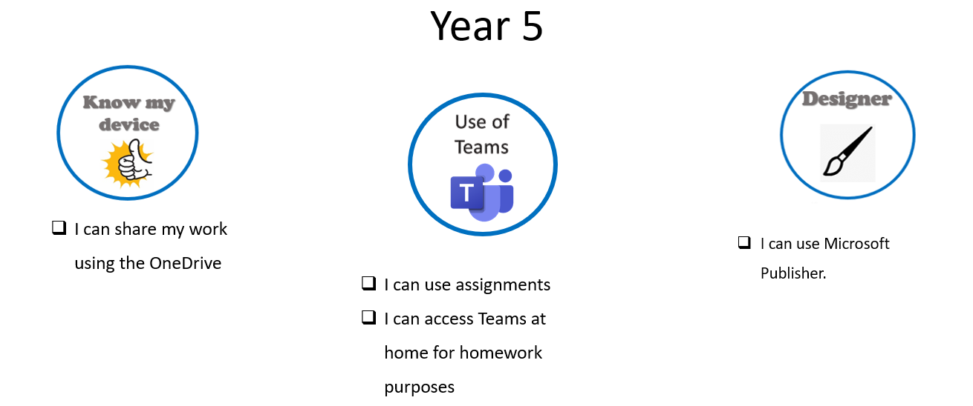

Year 6 | Lesson 1 | Lesson 2 | Lesson 3
Autumn 1  Computer Science | Barefoot computing – code cracking unit  Debugging learn how codes were used during WW2 to hide messages | https://hoc.lgfl.org.uk/  History of computing resource - Alan Turing and the impact coding had on hiding messages during WW2. | Create own codes in pairs to be broken
Autumn 2  Information Technology | Collecting, analysing, evaluating and presenting data and information design and create a range of programs, systems and content for a given audience
Spring 1  Digital Literacy | Lesson 1  Explain what app permissions are and can give some examples from the technology or services I use.  Describe simple ways to increase privacy on apps and services that provide privacy settings.  Describe ways in which some online content targets people to gain money or information illegally; I can  describe strategies to help me identify such content (e.g. scams, phishing). | Lesson 2  Describe ways in which media can shape ideas about gender.  Identify messages about gender roles and make judgements based on them.  Challenge and explain why it is important to reject inappropriate messages about gender online. | Lesson 3  Describe ways people who have similar likes and interests can get together online.  Identify the risks of communicating online with others I don’t know well.  Understand what it means to ‘know someone’ online and why this might be different from knowing someone in  real life.  Explain why I should be careful who I trust online and what information I can trust them with.
Spring 2  Information Technology | Lesson 1  Sand box – creating Polar landscapes  Learn how to use the functionality | Lesson 2  Create a polar scene using the tools | Lesson 3  Import the scene into I movie
Summer 1  Information Technology | Lesson 1  Show how to input into cell and how to read the cell reference. Children complete a template | Lesson 2  Show how to use auto sum and all the four operations into a real-world task. Practise activities | Lesson 3  Use of Excel to budget for a baby with a fixed cost. Links to flour baby week.
Summer 2  Computer Science |   This unit introduces your pupils to ideas about light, animals, energy resources, earthquakes and the transfer of information. They’ll explore these while helping Maria, Sofie, Leo, and Daniel investigate the ways people and animals understand and use the world around them. They’ll experience and explain how light reflects from objects and enters the eyes, which allows the object to be seen. They’ll explore how animals use internal and external structures to live, grow and survive in the world. They’ll learn about energy from natural resources and how their use by humans affects the environment. They’ll also research ways to decrease the impact of natural Earth processes on humans. Finally, they’ll design and compare multiple solutions that show how patterns can be used to transfer information.

